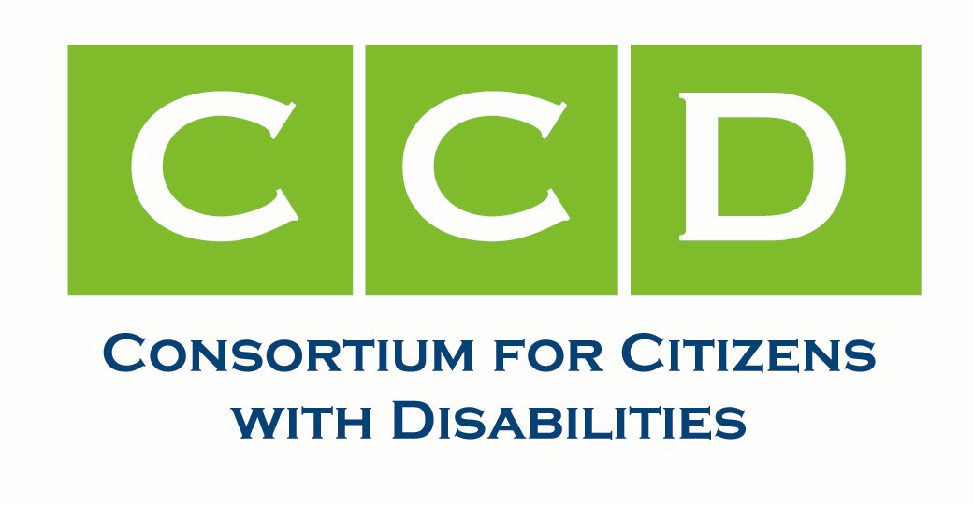

CCD Long Term Services and Supports Task Force Report

ISSUES/ACTIVITIES IN 2008

Medicaid Regulations
The LTSS Task Force worked collaboratively with the Health Task Force and a large coalition to oppose a series of seven Medicaid regulations that would shifts costs to states and result in harmful cuts in services to individuals with disabilities. Three of the seven rules would be particularly harmful to individuals with disabilities: 1) rehabilitation services option; 2) school-based administrative and transportation; and 3) case management. Efforts resulted in a major victory: a moratorium was included in the supplemental war appropriations bill which delays further implementation of six of the seven regulations until April 1, 2009. The outpatient rule was not included and subsequently has been finalized. The school-based and case management regulations are also currently in final form. CCD has provided recommendations to the transition team to act early to extend the moratorium if necessary and permanently withdraw and rescind these regulations.

Medicaid FMAP and Economic Recovery
The LTSS Task Force also worked in collaboration with the Health Task Force on letters submitted to Senate and House leadership and the Obama-Biden Transition Team urging support for an increased FMAP, with maintenance of effort provisions on eligibility and services, and an increased FMAP for Medicaid home and community-based services and supports in the economic recovery bill being drafted by Congress and the new Administration.

Community Living Assistance Services and Supports Act (CLASS Act)
The CLASS Act would establish a national, voluntary, premium-based long-term care insurance program, filling a major void in our national long term care system and helping relieve pressure on Medicaid as the sole payer of long-term care. This past year the LTSS Task Force worked in collaboration with the Leadership Council of Aging Organizations (LCAO) on efforts to advance the CLASS Act. CCD and LCAO finalized a set of joint principles on long-term services and supports financing reform. In November, CCD and LCAO issued a joint press release highlighting the principles and encouraging the next Administration and Congress to include long-term services and supports within comprehensive health care reform. The Health and LTSS Task Forces also sent letters and met with Senate leadership on priorities for health care reform that included recommendations on long-term services and supports.

Medicaid HCBS State Plan Option/Empowered at Home Act
The HCBS State Plan Option, which became available through the Deficit Reduction Act of 2005, provided states with the opportunity to expand community-based services without applying for a waiver. The HCBS Option also eliminated the requirement that individuals meet an “institutional” level of care to qualify for community-based services. In June, the LTSS Task Force submitted comments to CMS on a Notice of Proposed Rulemaking concerning the HCBS Option. CCD provided input into a new bill introduced by Senators Kerry (D-MA) and Grassley (R-IA) that would make needed legislative improvements to the HCBS Option, the Empowered at Home Act. The bill would: expand eligibility from 150% of the federal poverty line to 300% of SSI; provide flexibility to states to provide the full range of services that are currently allowed under the HCBS waiver (including “other services” approved by the Secretary); and eliminate caps or limits on state-wideness. A companion bill was introduced in the House which also includes an FMAP increase to incentivize states to take up the option.

Community Choice Act

The Community Choice Act would amend Medicaid to mandate State Medicaid plan coverage of community-based attendant services and supports for certain Medicaid-eligible individuals. Co-sponsorship is at its highest level and includes President-Elect Obama who frequently referenced his support during the campaign. CCD provided a briefing to LCAO on the Community Choice Act to assist with gaining support from the aging community. Efforts are being made to work with CBO on a new cost estimate in light of research which has re-estimated costs significantly lower than a previous CBO score nearly a decade ago.

Direct Support Professionals Fairness and Security Act

This bill would amend the Medicaid program to provide and enhanced FMAP to states to enable them to increase the wages paid to targeted direct support professionals in providing services to individuals with disabilities. In order to receive the enhanced FMAP, states would be required to submit a five-year plan and must assure continuation of the increased wage rate after the five-year period. CCD continued to work to raise awareness and co-sponsors.

Family Support
The LTSS Task Force worked in collaboration with LCAO on a joint sign on letter funding for family caregiver support programs. The letter was submitted to the House and Senate Labor-HHS-Education Appropriations subcommittees and urged increased funding for key family support programs including, the Lifespan Respite Care Act, the National Family Caregiver Support Program, and family support within the Developmental Disabilities Act. CCD also supported the Lifespan Respite Coalition in advocating for funding to implement the Lifespan Respite Care Act (P.L. 109-442), which was signed into law on December 21, 2006 but has received no appropriations. In addition, the LTSS Task Force worked on language for a technical correction to the National Family Caregiver Support Program to include older caregivers of adults with disabilities.

GOALS FOR 2009

The LTSSP Task Force will continue to work in collaboration with the Health Task Force to permanently withdraw and rescind harmful Medicaid regulations and support FMAP increases in the economic recovery plan. The Task Force will also continue to work in collaboration with LCAO and promote passage of the CLASS Act, Empowered at Home Act, Community Choice Act, and the Direct Support Professionals Fairness and Security Act. Efforts will focus on including long-term services and supports within comprehensive health care reform. Finally, the Task Force will continue collaborative efforts to promote and increase funding for family caregiver support programs.

CO-CHAIRS

Marty Ford, The Arc and UCP Disability Policy Collaboration
Joe Caldwell, Association of University Centers on Disabilities
Lee Page, Paralyzed Veterans of America

