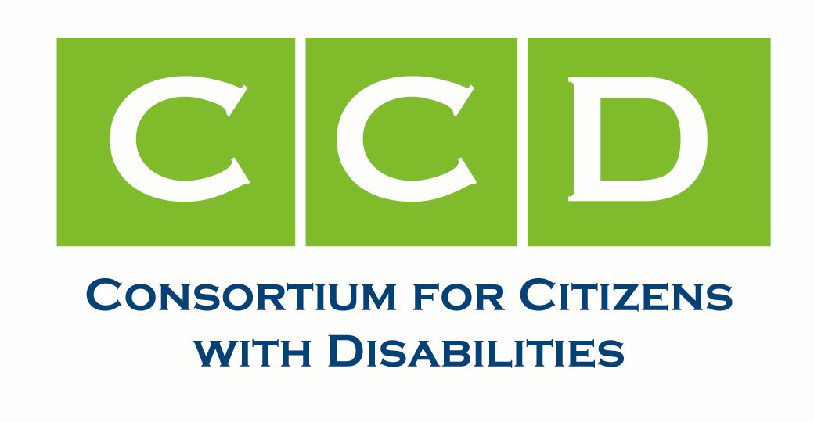
Transportation Task Force
2010 Annual Report

2010 in review

The Transportation Task Force continued work this year advocating for programs and supports that increase the mobility for people with disabilities. Our primary areas of work were the following:

- Continued Preparation for Transportation Legislation Reauthorization – Though technically up for renewal this year, the major transportation reauthorization that includes many of the programs of importance for people with disabilities was postponed until next year. The Task Force spent time developing principles and meeting with key congressional staff to share the priorities of CCD.
- Department of Transportation Regulations – The Department of Transportation reopened their guidance on Americans with Disabilities Act (ADA) standards for transit service provisions and rail platform issues. The Task Force participated in open meetings and submitted comment on this guidance.
- Negotiations with Amtrak – The deadline for all Amtrak stations to be fully accessible under the Americans with Disabilities Act (ADA) Was July 2010. For multiple reasons, Amtrak did not meet that deadline. Discussions have been ongoing with congressional staff, Amtrak and other interested parties on how to deal with this situation. The Task Force has strongly weighed in and been supported by members of Congress in negotiations to create a solution that helps Amtrak achieve accessibility as quickly as possible. New funding available to Amtrak and supported by CCD should help achieve this goal.
- Access Board Americans with Disabilities Act Guidelines - The Task Force submitted testimony and input into the Access Board’s ongoing efforts to develop final standards on vehicle accessibility under the ADA.

2011 Priorities

The Task Force foresees that the reauthorization of transportation legislation will take a significant amount of effort next year and that will make up the bulk of our work. We will continue to work on issues such as appropriations for transit programs, Amtrak/rail accessibility, and other issues as they arise.

Co-Chairs:

Jennifer Dexter – Easter Seals
Julie Ward – The Arc/UCP Disability Policy Collaboration

