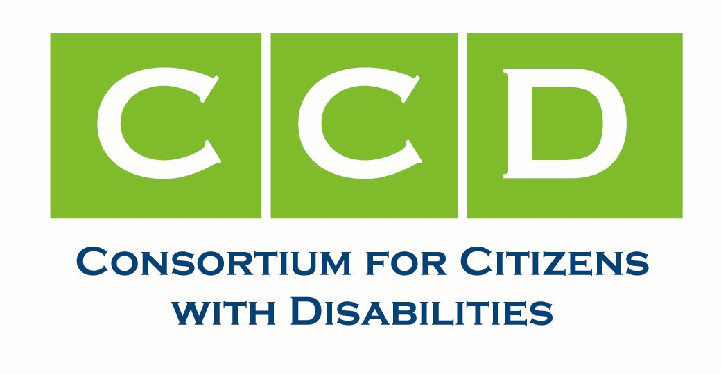

MEMBERSHIP DIRECTORY

2012

Rev. 7/30/2026

1825 K Street, NW, Suite 1200 • Washington, DC 20006 • PH 202/783-2229 • FAX 202/534-3731 • Info@c-c-d.org • www.c-c-d.org

NEW MEMBERS 2012

Advance CLASS Inc. (LFA)  1815 K Street, NW #600  Washington, DC 20036  (202) 349-1150 (office)  (202) 349-1156 (fax) | Connie Gardner cgarner@advanceclass.org  Kate Josephson

American Council on Rural Special  Education (ACRES)  509 Allen Hall  P.O. Box 6122  Morgantown, WV 26506-6122  (304) 293-3835 (office)  (304) 292-8945 (fax)  www.acres-sped.org | Barbara Ludlow acres-sped@mail.wvu.edu

Legal Action Center (LAC)  236 Massachusetts Ave., NE # 505  Washington, DC 20002  (202) 544-5478 (office)  (202) 544-5712 (fax) | Gabrielle de la Gueronniere  gdelagueronniere@lac-dc.org

Lupus Foundation of America (LFA)  2000 L Street, NW #410  Washington, DC 20036  (202) 349-1150 (office)  (202) 349-1156 (fax) | Kim Cantor cantor@lupus.org  Sara Change chang@lupus.org

National Health Law Program (NHeLP)  1444 I Street NW, @1105  Washington, DC 20005  (202) 289-7661 (office)  (202) 289-7724 (fax) | Mara Youdelman youdelman@healthlaw.org  David Machledt machledt@healthlaw.org

Special Needs Alliance (SNA)  6341 E. Brian Kent Drive  Tucson, AZ 85710  (520) 546-1005 (office)  (520) 546-5119 (fax) | Jihane Rohrbacker jihane@specialneedsalliance.org  Morris Klein morrisklein@netzero.net

